2024-2025-1《Java Web应用开发》上机测试题

**测试时间：12月24日 姓名: 何志超 学号: 2022511302**

请将文件名改成学号+姓名，如2022051224张三.docx。

假设有商品表和分类表，表结构和数据示例如下：

**商品表 goods**

|  |  |  |
| --- | --- | --- |
| **字段名** | **类型** | **说明** |
| id | int | 商品编号，自增，主键 |
| name | varchar | 商品姓名 |
| price | double | 商品价格 |
| intro | varchar | 商品介绍 |
| type_id | int | 外键，班级编号 |

商品表 示例：

|  |  |  |  |  |
| --- | --- | --- | --- | --- |
| **id** | **name** | **price** | **intro** | **type_id** |
| 1 | 充电宝 | 109.9 | 品牌商品，安全可靠 | 1 |
| 2 | 无线鼠标 | 45.9 | 双模无线、轻音充电 | 1 |
| 3 | U盘 | 65 | 闪迪，高速 | 1 |
| 4 | 手机支架 | 12.5 | 颜值高 | 2 |
| 5 | 保温杯 | 89.9 | 颜色多样，保温持久 | 2 |
| 6 | 活页笔记本 | 19.9 | 纸张厚实，书写顺滑 | 2 |

**类型表 type**

|  |  |  |
| --- | --- | --- |
| **字段名** | **类型** | **说明** |
| id | int | 类型编号，自增 |
| name | varchar | 类型名称 |

类型表 示例：

|  |  |
| --- | --- |
| **id** | **name** |
| 1 | 电子产品 |
| 2 | 生活用品 |
| 3 | 服装 |

根据上述两个表完成以下功能：

在IDEA中新建项目（项目名为**你的姓名全拼+12，如zhangsan12**），在MySQL中新建数据库为test1224，自行建立goods和type数据表，在项目中查询goods表，实现零件的关联表查询、删除、修改、新增功能。

在list.jsp（分页功能自愿做）显示所有的商品信息，具体的业务逻辑内容在Servlet中处理。要求：各个页面显示效果清晰有序，注意所有截图中须**包括浏览器地址栏**部分。

最后将整个项目+数据库压缩后提交至学习通，考试文档不压缩单独提交至学习通。

1.在list.jsp页面显示中所有信息的截图：

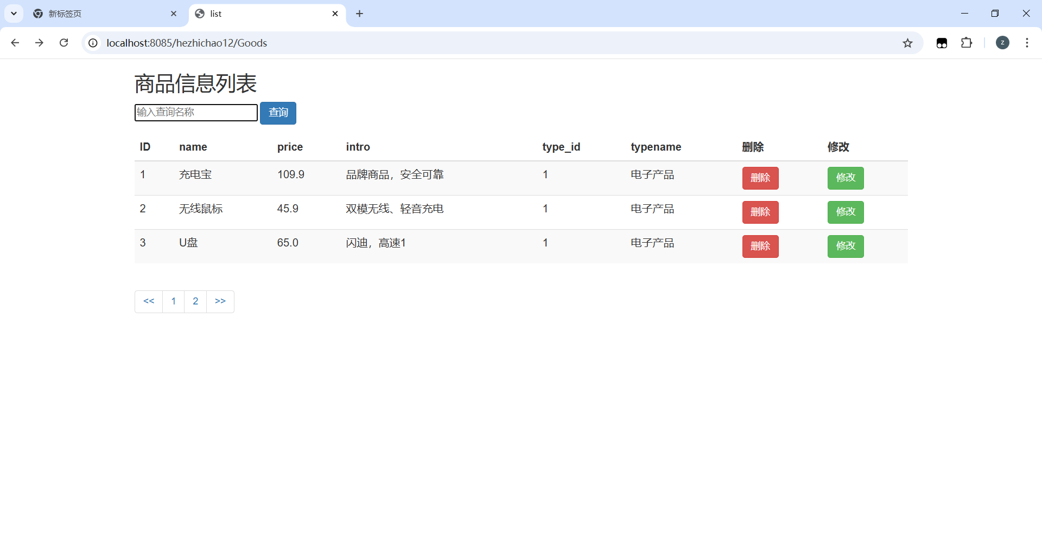

2.修改页面截图：

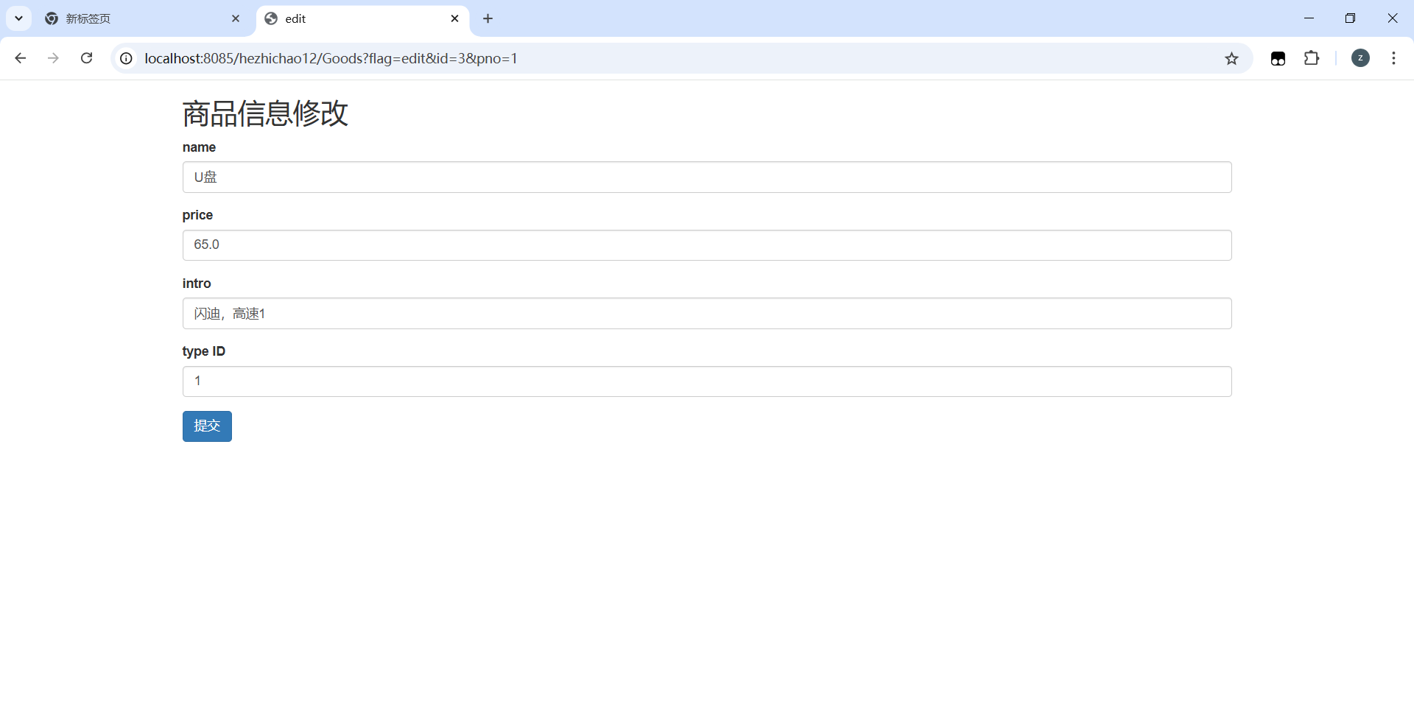

3.新增页面截图：

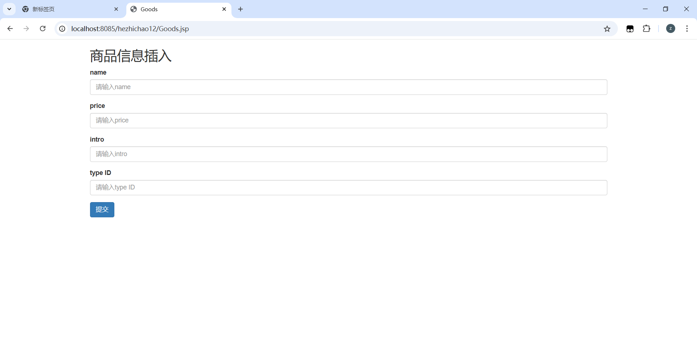

4.请将Servlet中的代码粘贴在下面：

package com.hezc.web;  
  
  
import com.hezc.bean.Goods;  
import com.hezc.dao.Goodsdao;  
  
import javax.servlet.ServletException;  
import javax.servlet.annotation.WebServlet;  
import javax.servlet.http.HttpServlet;  
import javax.servlet.http.HttpServletRequest;  
import javax.servlet.http.HttpServletResponse;  
import java.io.IOException;  
import java.util.List;  
  
@WebServlet(name = "GoodsServlet", value = "/Goods")  
public class GoodsServlet extends HttpServlet {  
 @Override  
 protected void doGet(HttpServletRequest request, HttpServletResponse response) throws ServletException, IOException {  
 request.setCharacterEncoding("UTF-8");  
 response.setContentType("text/html;charset=utf-8");  
 response.setCharacterEncoding("UTF-8");  
  
 String flag=request.getParameter("flag");  
 Goodsdao Goodsdao=new Goodsdao();  
 int psize=3;  
 if(flag==null||"list".equals(flag)){  
 String pnos=request.getParameter("pno");  
 if(pnos==null||pnos.equals("")){  
 pnos="1";  
 }  
 int pno=Integer.*parseInt*(pnos);  
 int start=(pno-1)*psize;  
 int count= Goodsdao.count();  
 int pcount=(count+psize-1)/psize;  
 List<Goods> list=Goodsdao.getall(start,psize);  
 request.setAttribute("pno",pno);  
 request.setAttribute("pcount",pcount);  
 request.setAttribute("list",list);  
 request.getRequestDispatcher("list.jsp").forward(request,response);  
 } else if ("delete".equals(flag)) {  
 Integer id =Integer.*parseInt*(request.getParameter("id"));  
 Integer pno=Integer.*parseInt*(request.getParameter("pno"));  
 Goodsdao.delete(id);  
 response.sendRedirect("Goods?pno="+pno);  
  
 } else if ("insert".equals(flag)) {  
 String name= request.getParameter("name");  
 Double price=Double.*parseDouble*(request.getParameter("price"));  
 String intro=request.getParameter("intro");  
 Integer type_id=Integer.*parseInt*(request.getParameter("type_id"));  
  
 Goods goods=new Goods();  
 goods.setName(name);  
 goods.setIntro(intro);  
 goods.setPrice(price);  
 goods.setType_id(type_id);  
  
 Goodsdao.insert(goods);  
  
 response.sendRedirect("Goods");  
  
  
 }else if ("get".equals(flag)) {  
 String name=request.getParameter("name");  
  
 List<Goods> list=Goodsdao.get(name);  
 request.setAttribute("list",list);  
 request.getRequestDispatcher("list.jsp").forward(request,response);  
  
 } else if ("edit".equals(flag)) {  
 Integer id=Integer.*parseInt*(request.getParameter("id"));  
 Integer pno=Integer.*parseInt*(request.getParameter("pno"));  
 Goods getbyid = Goodsdao.getbyid(id);  
 request.setAttribute("g",getbyid);  
  
 request.getRequestDispatcher("edit.jsp").forward(request,response);  
  
 } else if ("update".equals(flag)) {  
 String name= request.getParameter("name");  
 Double price=Double.*parseDouble*(request.getParameter("price"));  
 String intro=request.getParameter("intro");  
 Integer type_id=Integer.*parseInt*(request.getParameter("type_id"));  
  
 Goods goods=new Goods();  
 goods.setName(name);  
 goods.setIntro(intro);  
 goods.setPrice(price);  
 goods.setType_id(type_id);  
  
 goods.setId(Integer.*parseInt*(request.getParameter("id")));  
  
 Goodsdao.update(goods);  
 response.sendRedirect("Goods");  
  
 }  
 }  
  
 @Override  
 protected void doPost(HttpServletRequest request, HttpServletResponse response) throws ServletException, IOException {  
this.doGet(request,response);  
 }  
}

5.请将GoodsDao的内容粘贴在此处：

package com.hezc.dao;  
  
import com.hezc.bean.Goods;  
import org.apache.commons.dbutils.QueryRunner;  
import org.apache.commons.dbutils.handlers.BeanHandler;  
import org.apache.commons.dbutils.handlers.BeanListHandler;  
import org.apache.commons.dbutils.handlers.ScalarHandler;  
  
import java.sql.SQLException;  
import java.util.List;  
  
public class Goodsdao {  
 QueryRunner runner=new QueryRunner(C3p0Utils.*getDataSource*());  
  
  
 public int count(){  
  
 Long r=0l;  
 String sql="select count(*) from goods";  
 try {  
 r=runner.query(sql,new ScalarHandler<>());  
 } catch (SQLException e) {  
 throw new RuntimeException(e);  
 }  
 return r.intValue();  
 }  
 public List<Goods> getall(int start, int psize){  
  
 String sql="select g.*,t.name typename from goods g,type t where g.type_id=t.id limit ?,?";  
 List<Goods> list=null;  
  
 try {  
 list=runner.query(sql,new BeanListHandler<>(Goods.class),start,psize);  
 } catch (SQLException e) {  
 throw new RuntimeException(e);  
 }  
 return list;  
  
 }  
 public void delete(int id){  
 String sql="delete from goods where id=?";  
 try {  
 runner.update(sql,id);  
 } catch (SQLException e) {  
 throw new RuntimeException(e);  
 }  
 }  
 public void insert (Goods g){  
 String sql="insert into goods(name,price,intro,type_id) values (?,?,?,?)";  
 try {  
 runner.update(sql,g.getName(),g.getPrice(),g.getIntro(),g.getType_id());  
 } catch (SQLException e) {  
 throw new RuntimeException(e);  
 }  
  
 }  
 public Goods checkname(String name){  
 String sql="select * from student where name=?";  
 try {  
 return runner.query(sql,new BeanHandler<>(Goods.class),name);  
 } catch (SQLException e) {  
 throw new RuntimeException(e);  
 }  
  
 }  
 public List<Goods> get(String name){  
 String sql="select g.*,t.name typename from goods g,type t where g.type_id=t.id and g.name like ?";  
 String name1="%"+name+"%";  
 try {  
 return runner.query(sql,new BeanListHandler<>(Goods.class),name1);  
 } catch (SQLException e) {  
 throw new RuntimeException(e);  
 }  
 }  
 public Goods getbyid(int id){  
 String sql="select g.*,t.name typename from goods g,type t where g.type_id=t.id and g.id=?";  
 Goods goods=null;  
 try {  
 goods=runner.query(sql,new BeanHandler<>(Goods.class),id);  
 } catch (SQLException e) {  
 throw new RuntimeException(e);  
 }return goods;  
 }  
 public void update(Goods g){  
 String sql="update goods set name=?,price=?,intro=?,type_id=? where id=?";  
 try {  
 runner.update(sql,g.getName(),g.getPrice(),g.getIntro(),g.getType_id(),g.getId());  
 } catch (SQLException e) {  
 throw new RuntimeException(e);  
 }  
  
 }  
  
  
}

6.list.jsp中的所有代码粘贴在此处：

<%@ **taglib** prefix="c" uri="http://java.sun.com/jsp/jstl/core" %>  
<%--  
 Created by IntelliJ IDEA.  
 User: he  
 Date: 2024/12/18  
 Time: 8:15  
 To change this template use File | Settings | File Templates.  
--%>  
<%@ **page** contentType="text/html;charset=UTF-8" language="java" %>  
<**c:set** var="ctx" value="${pageContext.request.contextPath}"/>  
<html>  
 <head>  
 <title>list</title>  
 <link rel="stylesheet" href="${ctx}/css/bootstrap.css">  
 </head>  
 <body>  
 <div class="container mt-5">  
 <h2>商品信息列表</h2>  
 <form action="Goods?flag=get" method="post">  
 <input type="text" name="name" placeholder="输入查询名称">  
 <input type="submit" value="查询" class="btn btn-primary">  
 </form>  
 <table class="table table-striped">  
 <thead>  
 <tr>  
 <th scope="col">ID</th>  
 <th scope="col">name</th>  
 <th scope="col">price</th>  
 <th scope="col">intro</th>  
 <th scope="col">type_id</th>  
 <th scope="col">typename</th>  
 <th scope="col">删除</th>  
 <th scope="col">修改</th>  
 </tr>  
 </thead>  
 <tbody id="studentTableBody">  
 <**c:forEach** var="s" items="${list}">  
 <tr>  
 <td>${s.id}</td>  
 <td>${s.name}</td>  
 <td>${s.price}</td>  
 <td>${s.intro}</td>  
 <td>${s.type_id}</td>  
 <td>${s.typename}</td>  
 <td><a href="${ctx}/Goods?flag=delete&id=${s.id}&pno=${pno}" class="btn btn-danger">删除</a></td>  
 <td><a href="${ctx}/Goods?flag=edit&id=${s.id}&pno=${pno}" class="btn btn-success">修改</a></td>  
 </tr>  
 </**c:forEach**>  
  
 </tbody>  
 </table>  
  
  
  
  
 <ul class="pagination">  
 <li><a href="${ctx}/Goods?pno=${pno-1>0?pno-1:1}"><<</a></li>  
 <**c:forEach** var="i" begin="1" end="${pcount}">  
 <li><a href="${ctx}/Goods?pno=${i}">${i}</a></li>  
 </**c:forEach**>  
 <li><a href="${ctx}/Goods?pno=${pno<pcount?pno+1:pcount}">>></a></li>  
 </ul>  
  
   
 </div>  
  
 </body>  
</html>

7.修改商品信息的第一步的表单页面（edit.jsp）代码粘贴在此处：

<%@ **taglib** prefix="c" uri="http://java.sun.com/jsp/jstl/core" %>  
<%--  
 Created by IntelliJ IDEA.  
 User: he  
 Date: 2024/12/18  
 Time: 9:42  
 To change this template use File | Settings | File Templates.  
--%>  
<%@ **page** contentType="text/html;charset=UTF-8" language="java" %>  
<**c:set** var="ctx" value="${pageContext.request.contextPath}"/>  
<html>  
<head>  
 <title>edit</title>  
 <link rel="stylesheet" href="${ctx}/css/bootstrap.css">  
  
 <script type="text/javascript" src="${ctx}/js/jquery.min.js"></script>  
 <script type="text/javascript" src="${ctx}/js/bootstrap.min.js"></script>  
  
 <script>  
  
  
 function checkname(name){  
 $.post(  
 "Goods?flag=checkname",  
 {name1:name},  
 function (data){  
 if(data==1){  
 $(".namemsg").html("用户名重复");  
  
 }  
 else{  
 $(".namemsg").html("不重复，可以使用")  
  
 }  
 }  
 );  
 }  
  
 </script>  
</head>  
<body>  
  
<div class="container mt-5">  
 <h2>商品信息修改</h2>  
 <form action="${ctx}/Goods?flag=update&id=${g.id}" method="post">  
 <div class="form-group">  
 <label for="name">name</label>  
 <input type="text" class="form-control" id="name" name="name" value="${g.name}">  
 <span class="namemsg" style="color: red"></span>  
 </div>  
 <div class="form-group">  
 <label for="price">price</label>  
 <input type="number" class="form-control" id="price" name="price" value="${g.price}">  
 </div>  
 <div class="form-group">  
 <label for="intro">intro</label>  
 <input type="text" class="form-control" id="intro" name="intro" value="${g.intro}">  
 </div>  
 <div class="form-group">  
 <label for="type_id">type ID</label>  
 <input type="text" class="form-control" id="type_id" name="type_id" value="${g.type_id}">  
 </div>  
 <button type="submit" class="btn btn-primary">提交</button>  
 </form>  
</div>  
</body>  
</html>

8.项目结构截图粘贴在此处，样例如下

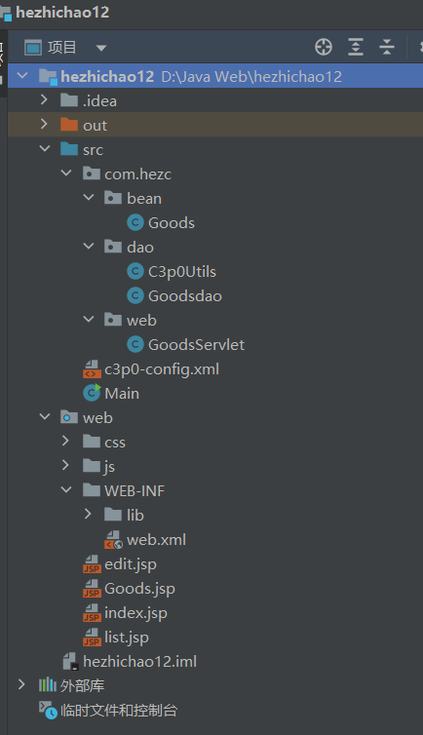

9.把你在完成此作业时出现的500错误或者404错误截图两张放置在此处

